IAM group

Group of IAM user is IAM Group

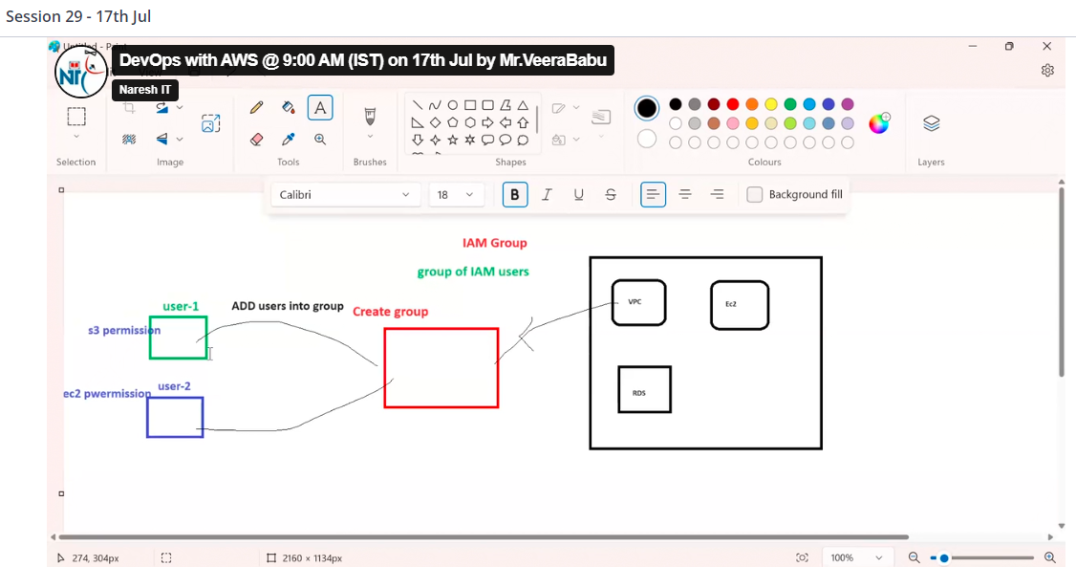

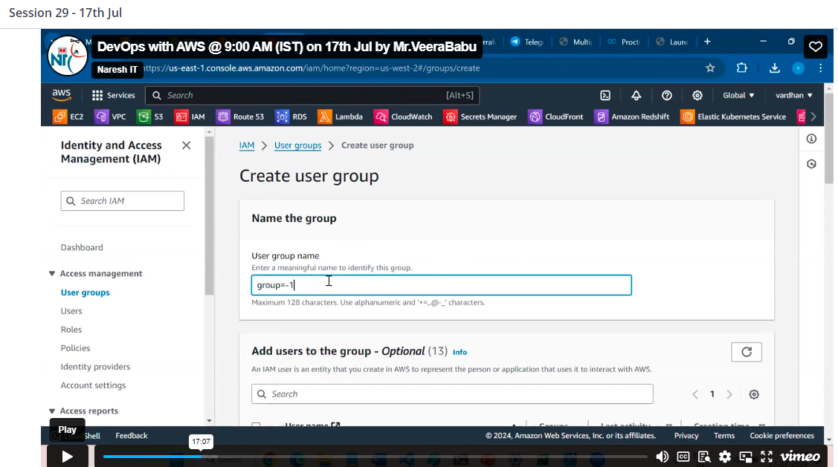

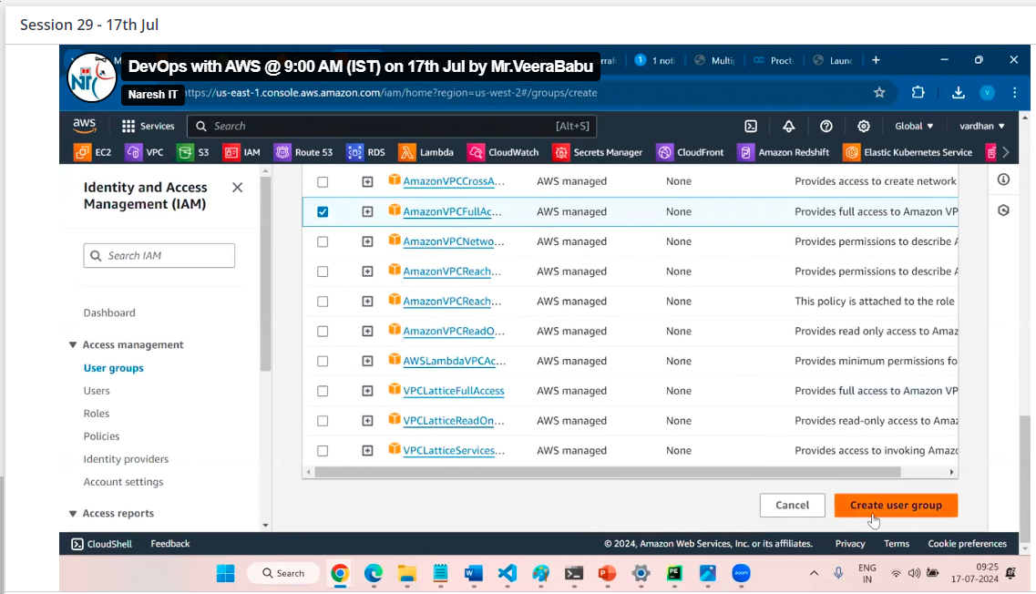

Now you can add user into group those you required permission

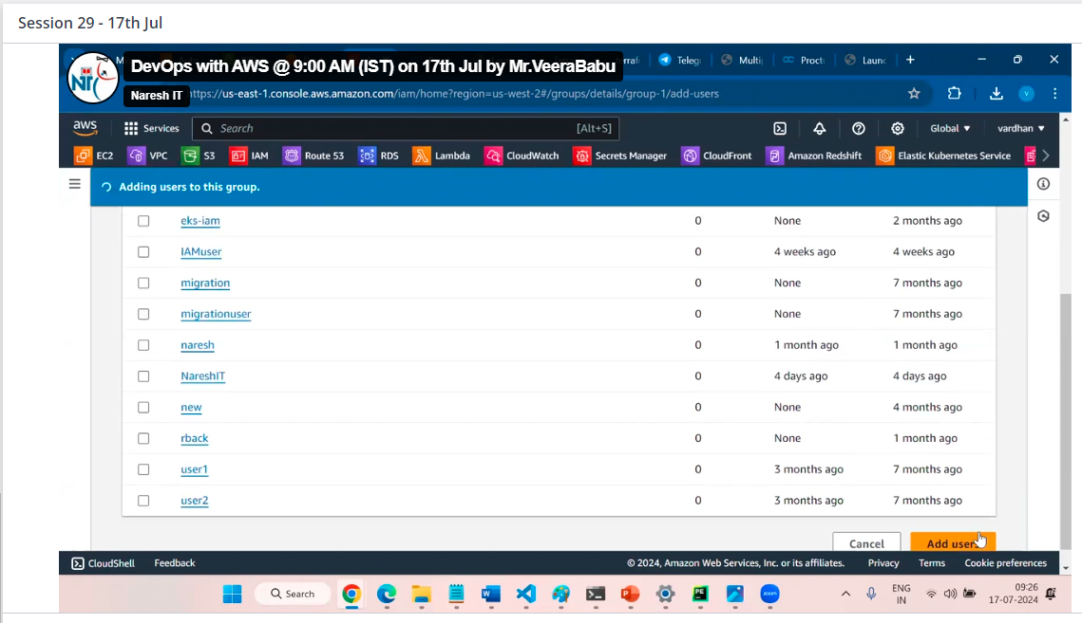

The group permission for only users added on group but the individual policies remains same

Individual permission of user works like individual only it will not over ride

Before we have seen cli connection from external 1.by console, 2.by command prompt, now we can see cli connection after connection to ec2 server

Two ways of connection after ec2 connection

1.Root user connection

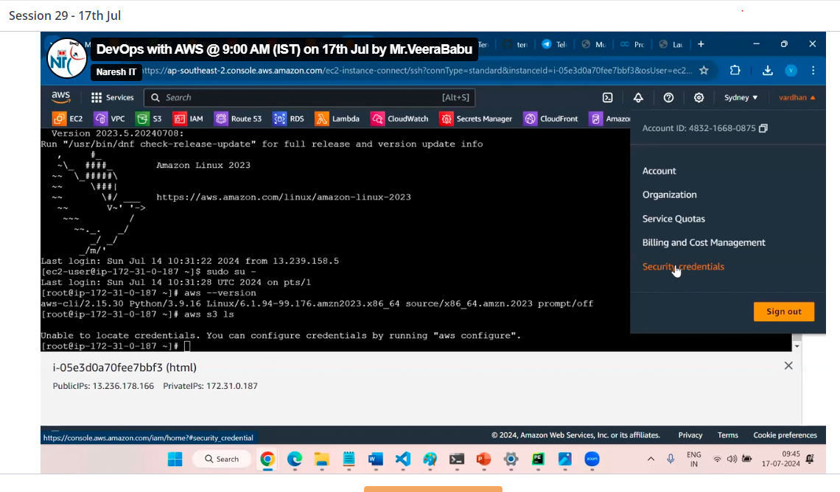

By security credentials, of access key & secret access key

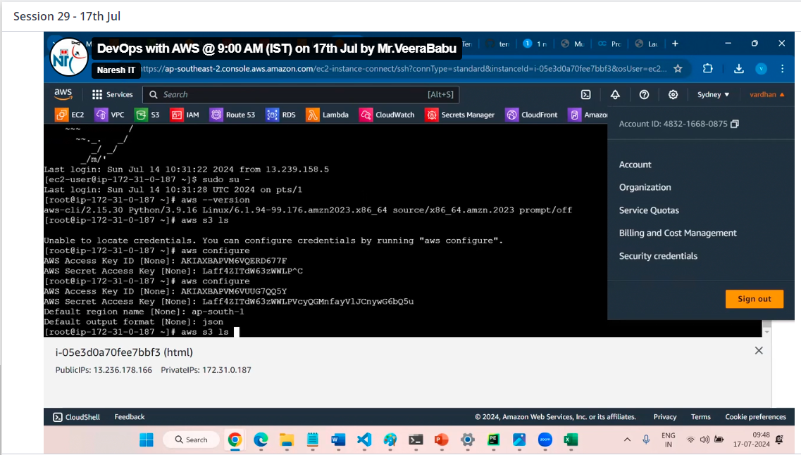

User login

2. By using user keys we can login as user from ec2 server

3.IAM roles

IAM roles it is like a user we can give the permissions to role and use that role for access purpose

The concept role helps here without configure any keys we can access, we can run directly like command to communicate any service

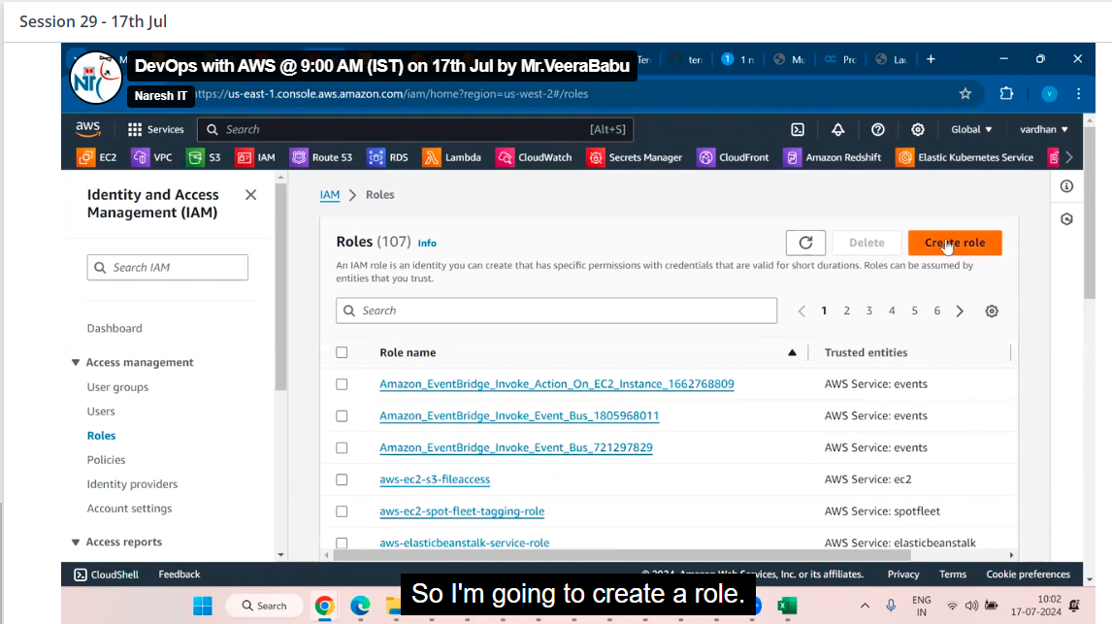

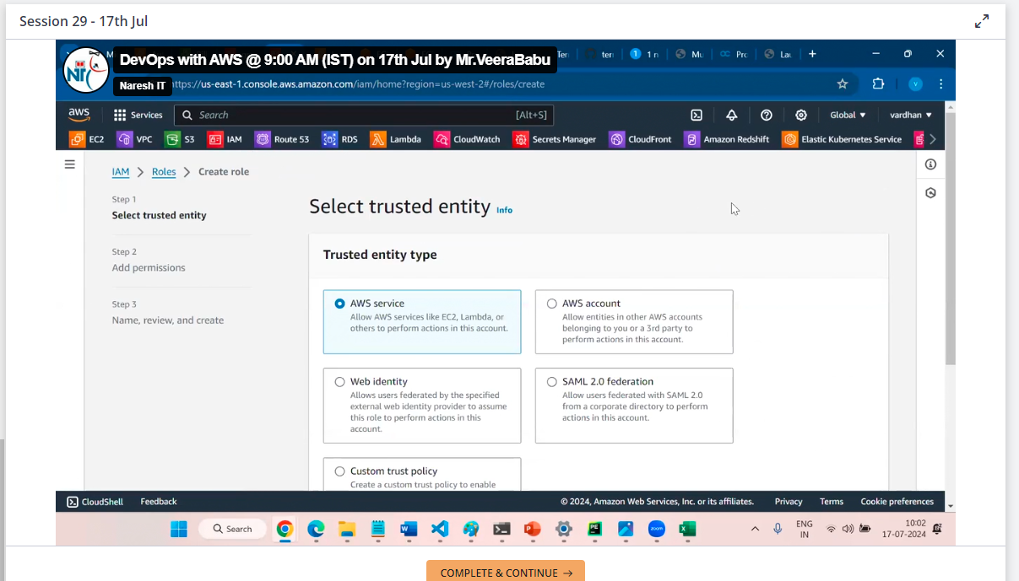

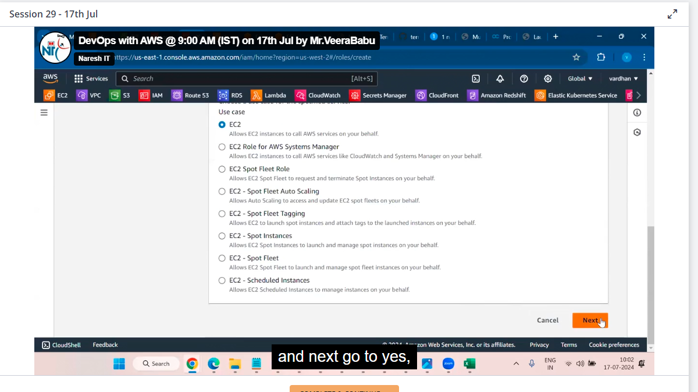

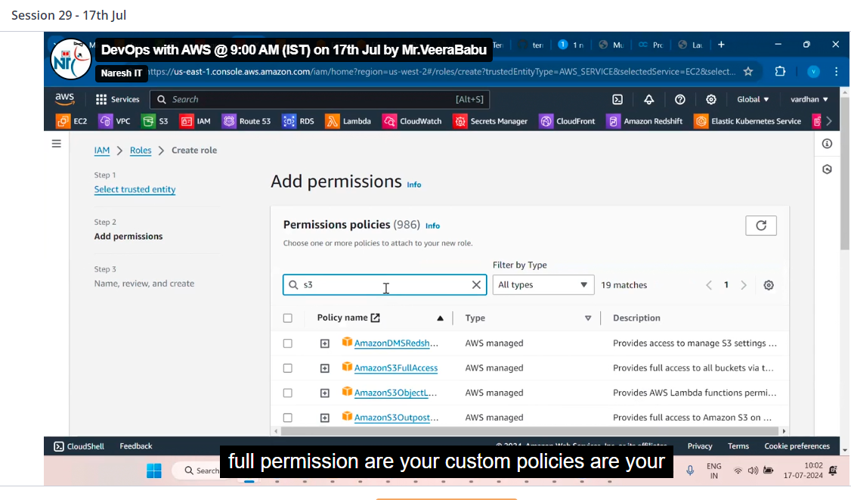

And click on next

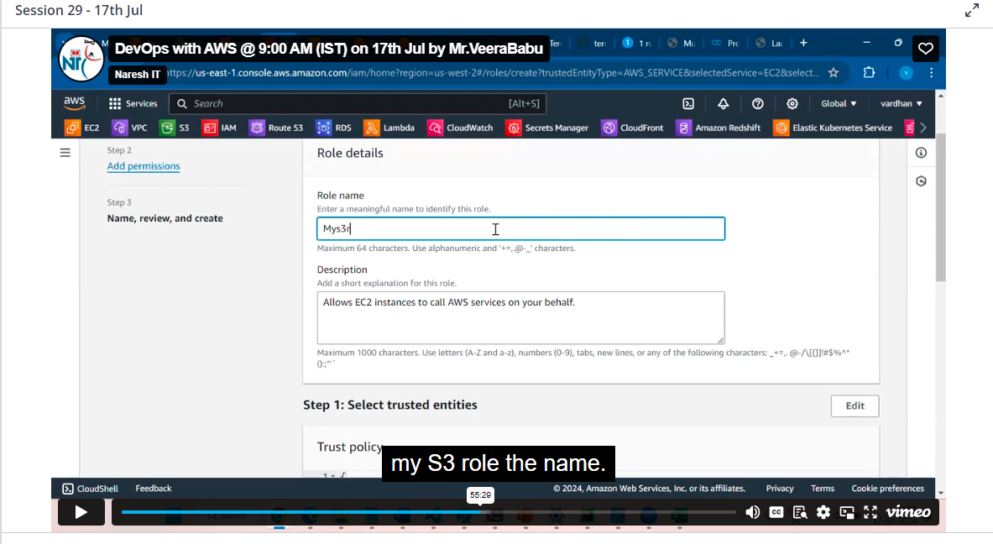

Click on create a role

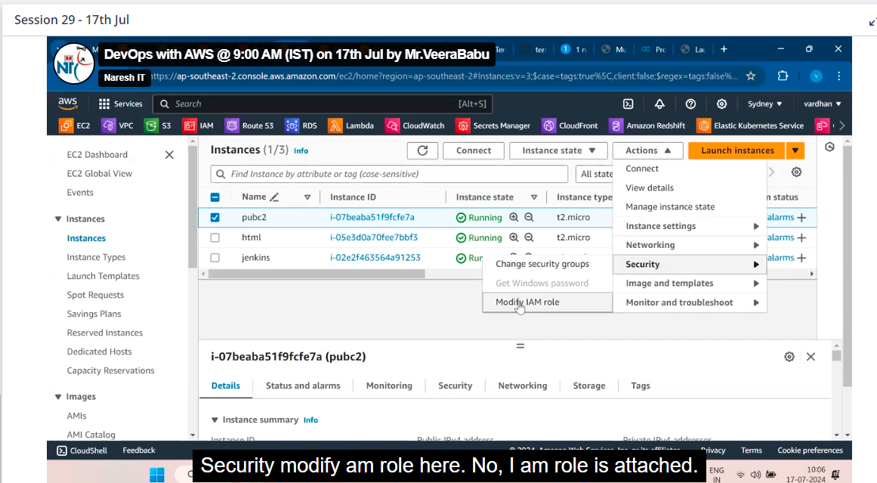

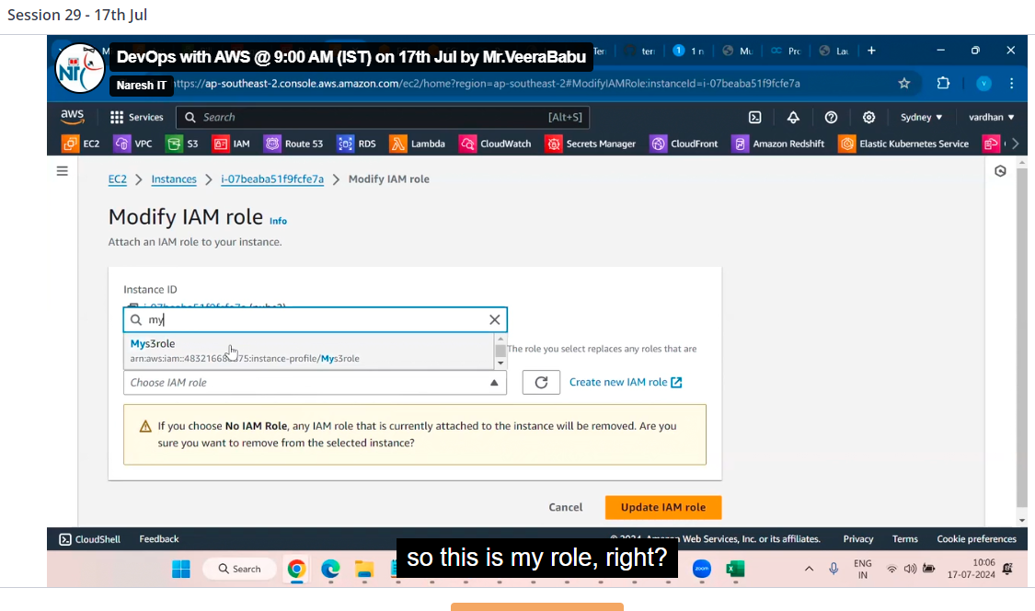

Then click on update IAM

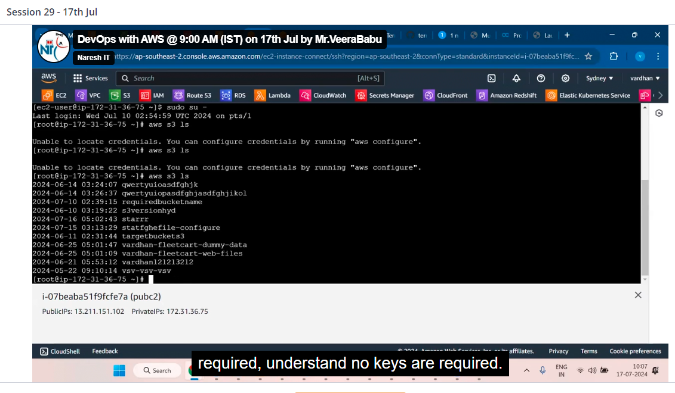

There is no credentials to login like user

IAM role helps the user to give the permissions to required service only but user can login, IAM cannot login